Contents
1. Project Overview 3
1.1 Project Title 3
1.2 Objective 3
1.3 Scope 3
1.4 Stakeholders 4
2. Software Requirements Specification 4
2.1 Functional Requirements 4
2.2 Non-Functional Requirements 5
2.3 User Stories/Use Cases 6
2.4 System Constraints 6
3. System Design 6
3.1 Architecture 7
3.2 Data Model 7
3.3 Module Design 8
3.4 Interfaces 8
4. Technology Stack 9
5. Development Plan 9
5.1 Methodology 9
5.2 Milestones 9
5.3 Task Breakdown 10
6. Development Plan 10
6.1 Coding Standards 10
6.2 Version Control 11
6.3 Modular Code 11
7. Testing & Quality Assurance 11
7.1 Unit Testing 11
7.2 Integration Testing 11
7.3 System Testing 11
7.4 User Acceptance Testing (UAT) 12
8. Documentation 12
8.1 Code Documentation 12
8.2 User Manual 12
8.3 API Documentation 12
9. Deployment 13
9.1 Environment Setup 13
9.2 Automation 13
9.3 Monitoring 13
10. Maintenance & Updates 13
10.1 Bug Fixes 13
10.2 Feature Updates 13
10.3 Performance Monitoring 14
11. Design Patterns 14

Project Overview

Project Title
Attend Smart: Face Recognition Attendance System

Objective

The system shall provide an automated, secure, and user-friendly solution for managing attendance using face recognition, streamlining administrative and teaching tasks for educational institutions.

Scope
The system provides:
- Real-time face recognition via webcam using OpenCV 4.5+.
- Role-based access for administrators and teachers.
- Course and enrollment management integrated with attendance tracking.
- Storage of face encodings in Pickle files and data in MySQL 8.0.
- Interactive GUI using Flet 0.21 for user operations.
- Exportable attendance reports in CSV format.
Limitations:
- Requires consistent lighting for optimal face detection.
- Limited to pre-registered students.
Comparison:
Manual systems are slow; fingerprint biometrics are costly and less scalable than face recognition.

Stakeholders

- Developers: Software team responsible for system implementation.
- Clients: Educational institution (school or universities) administrators.
- Users: Administrators (manage system), teachers (take attendance), students (recognized for attendance).

Software Requirements Specification

Functional Requirements

Code | Requirement Title | Description
FR1 | User Authentication | FR1.1: The system shall authenticate admins and teachers using a username and password.
FR1 | User Authentication | FR1.2: The system shall redirect authenticated admins to the admin dashboard and teachers to the teacher dashboard.
FR1 | User Authentication | FR1.3: The system shall send a login success email to teachers via SendGrid.
FR2 | Admin Data Management | FR2.1: The system shall allow admins to add, update, and delete records for students, teachers, courses, sections, and enrolment’s.
FR2 | Admin Data Management | FR2.2: The system shall validate inputs such as unique course codes and valid section names.
FR3 | Face Recognition Training | FR3.1: The system shall generate face encodings from student photos.
FR3 | Face Recognition Training | FR3.2: The system shall store the face encodings in a “EncodeFile”
FR4 | Attendance Marking | FR4.1: The system shall allow teachers to mark attendance using webcam-based face recognition for selected courses and sections.
FR4 | Attendance Marking | FR4.2: The system shall provide audio feedback (beep and TTS) for each recognized student.
FR5 | Attendance Management | FR5.1: The system shall allow teachers to view and edit attendance by course, section, and date.
FR5 | Attendance Management | FR5.2: The system shall generate Excel attendance reports.
FR5 | Attendance Management | FR5.3: The system shall send attendance reports via email using SendGrid.

Non-Functional Requirements

Code | Category | Description
NFR1 | Performance | The system shall process face recognition within 5 seconds per frame under standard lighting conditions.
NFR1 | Performance | The system shall load dashboard pages within 3 seconds.
NFR2 | Security | The system shall restrict admin functions to authenticated admins only.
NFR3 | Usability | The system shall feature a consistent dark-themed UI with intuitive navigation.
NFR3 | Usability | The system shall provide clear error messages via alert dialogs.
NFR4 | Reliability | The system shall maintain 99% uptime for database operations.
NFR4 | Reliability | The system shall handle webcam failures gracefully with user alerts.
NFR5 | Scalability | The system should support up to 1,000 students and 100 teachers per institution, limited by desktop deployment.
NFR6 | Maintainability | The system shall use modular code with inline comments for ease of updates.

User Stories/Use Cases

- US1: As an administrator, I want to register a student’s face and details to enable attendance tracking.
- US2: As a teacher, I want to log in, select a course, and initiate attendance, viewing real-time results on the GUI.
- US3: As an administrator, I want to create and manage courses and enroll students for accurate attendance.
- US4: As an administrator, I want to export attendance reports filtered by course or date for record-keeping.
- US5: As a teacher, I want to access a dashboard showing attendance summaries and course details.
- US6: As an administrator, I want to manage user accounts (add/remove teachers) to control system access.

System Constraints

- The system shall run on Windows with a webcam and MySQL server, limiting cross-platform support.
- The system should use Python 3.8+ and Flet for the UI, restricting alternative frameworks.
- The system requires a SendGrid API key for email functionality, limiting email provider options.
- The system shall depend on local storage for face encodings (EncodeFile.p), limiting scalability for large datasets.
- The system shall not support real-time analytics or multi-institution data separation, a significant limitation.

System Design

Architecture

The system adopts a modular Model-View-Controller (MVC) architecture:
- Model: MySQL 8.0 for relational data (users, students, courses, enrollments, attendance); Pickle files for face encodings.
- View: Flet 0.21 (preferred) GUI with role-based screens (login, dash-board, registration, attendance, course management, reports).
- Controller: Python modules (login.py, dashboard.py, register.py, mark_attendance. py, manage_attendance.py, course.py, enrollment.py, reports.py) managing logic, authentication, and data flow.

Data Model

Entity-Relationship Diagram (ERD):
Entities:
- Teacher: (Teacher_ID, Username, Password , Email, Phone)
- Student: (Roll_NO, Full_Name, Section_ID, PhotoSample)
- Course: (Course_ID, CourseCode, CourseName, CreditHours)
- Enrollment: (Teacher_ID, Section_ID, Course_ID)
- Attendance: (Attendance_ID, Roll_NO, Course_ID, Teacher_ID, Section_ID, Date, Time, Status [Present/Absent])
- Section: (Section_ID, Name, Deaprtment, Semester)
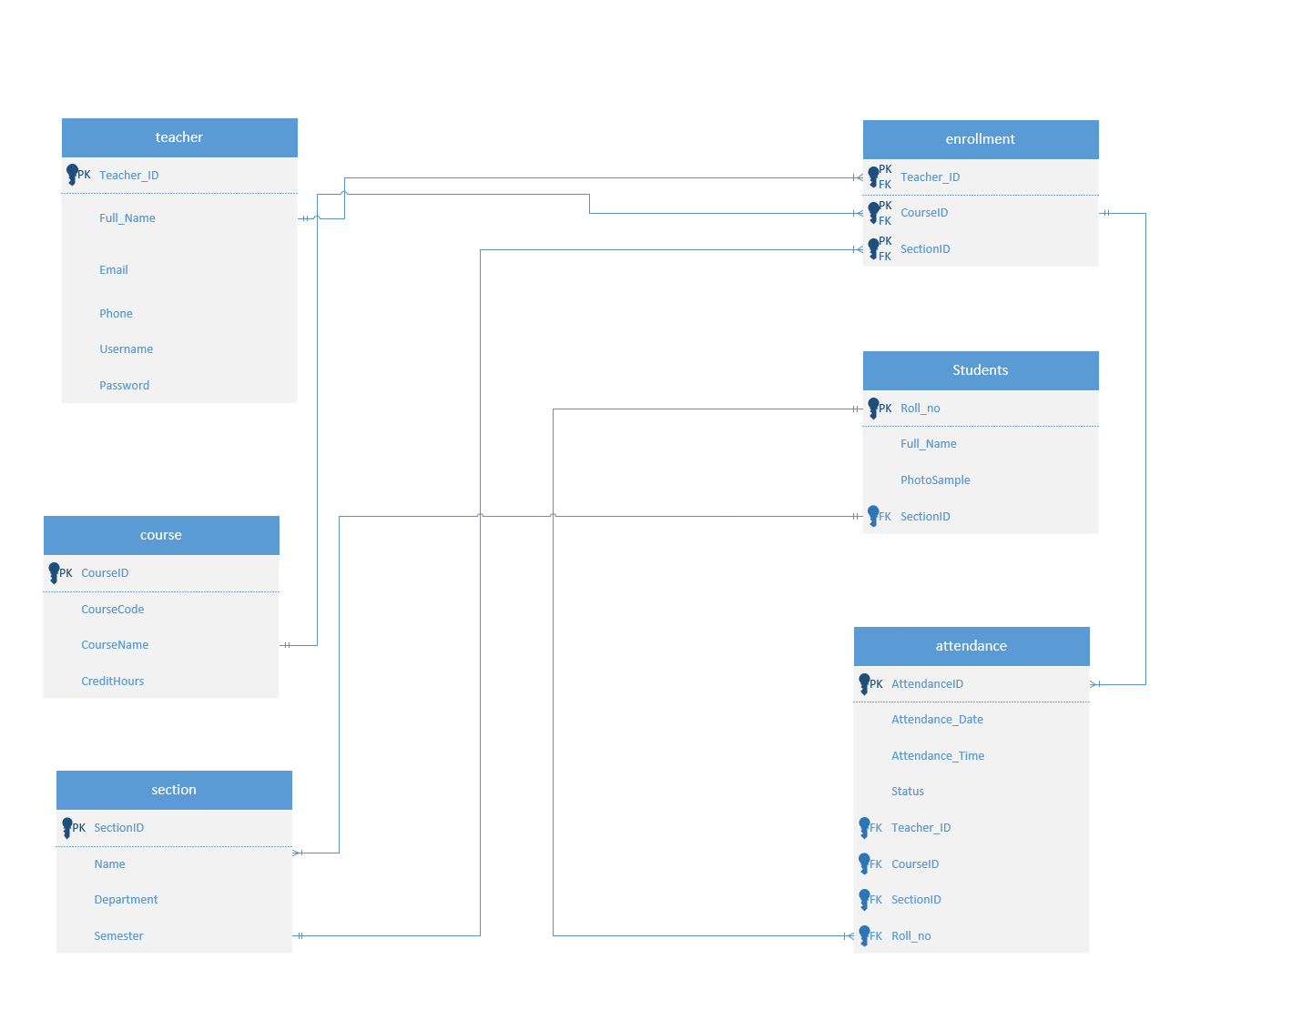
Relationships:
- One Teacher → Many Courses
- One Student → Many Enrollments
- One Course → Many Enrollments
- One Student → Many Attendances Records
- One Course → Many Attendances Records
Data Flow:
- Webcam → OpenCV Face Detection → Recognition (Pickle encodings) → MySQL Update (attendance) → GUI Update (Flet)
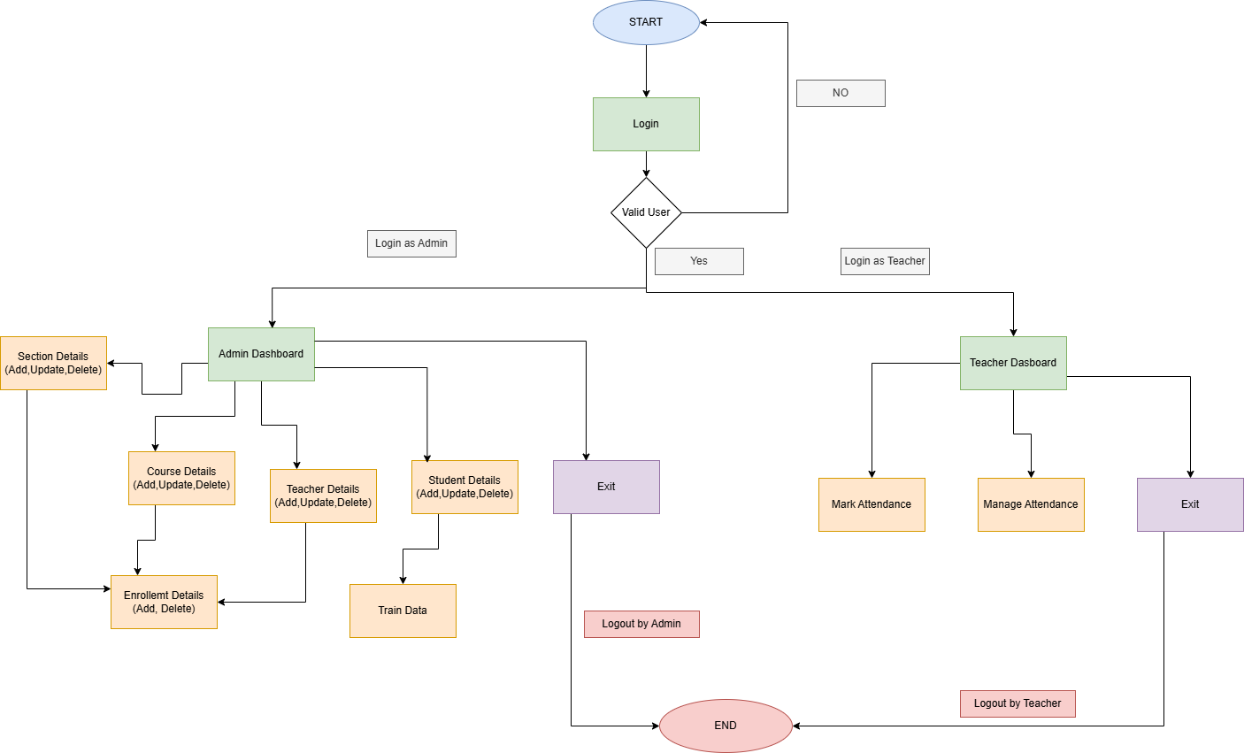

Module Design

- Authentication Module:
Handles user login functionality and sends automated email notifications upon successful authentication.
- Admin Modules:
Manage data related to students, teachers, courses, sections, and enrollments through CRUD operations and validations.
- Training Module:
Generates and stores face encodings from student images for use in facial recognition.
- Attendance Modules:
Handle real-time face recognition for attendance marking and provide features for viewing, editing, and managing attendance records.
- Navigation Modules:
Support user interface navigation, including splash screens, admin and teacher dashboards, and back button functionality.

Interfaces

- Internal Interfaces:
Uses MySQL queries for CRUD operations and the face_recognition library for face detection and matching.
- External Interfaces:
Provides a dark-themed user interface featuring radial gradients, DataTables for viewing records, input fields for data entry, and animated buttons for improved user interaction.

Technology Stack

- Frontend:
Flet 0.21 (preferred for modern, responsive UI, Python’s built-in GUI framework).
- Backend:
Python 3.8+, OpenCV 4.5+ (face detection/recognition), Pickle (face encoding serialization).
- Database:
MySQL 8.0 (robust relational database for structured data).
- Tools:
Version Control: Git (GitHub repository for collaboration).
IDE: VS Code or PyCharm for development.
Dependencies: opencv-python 4.5+, numpy 1.24+, pillow 9.5+, flet 0.21+, mysql-connector-python 8.0+.
- Email:
SendGrid API for sending automated emails, such as login alerts and attendance reports.

Development Plan

Methodology

The system uses an Agile methodology with two-week sprints for iterative development and testing. Each sprint focuses on delivering functional modules, incorporating feedback, and ensuring incremental progress toward the complete system.

Milestones

- M1: Database Setup and Authentication (Week 2)
Completed the database schema and implemented user login functionality for admins and teachers.
- M2: Admin Data Management Modules (Week 4)
Implemented management features for courses, students, teachers, sections, and enrollments.
- M3: Face Recognition and Attendance Modules (Week 6)
Developed face encoding functionality and implemented webcam-based attendance marking and attendance management features.
- M4: Testing and Deployment (Week 8)
Conducted manual testing of all core modules and deployed the system in a local Windows environment.

Task Breakdown

- Database:
Creates the database schema and populates sample data to support testing and development.
- UI:
Develops Flet-based user interfaces featuring a consistent dark theme and radial gradients across the splash screen, dashboards, and other application modules.
- Backend:
Implements CRUD operations for data management (e.g., courses, students), face recognition using face_recognition and OpenCV, and email integration using SendGrid.
- Testing:
Performs unit tests for individual functions (e.g., course validation) and integration tests for workflows (e.g., login to attendance marking).

Development Plan

Coding Standards

- Adhere to PEP 8 for Python code consistency.
- Use descriptive variable names.
- Provide docstrings for all modules, classes, and functions.

Version Control

- Repository: GitHub for version tracking.
- Branching: main (production), dev (development), feature branches (e.g., feature/attendance).

Modular Code

- Each module should be reusable, testable, and documented with inline comments.
- Reusable functions for face detection, database operations, and GUI updates

Testing & Quality Assurance

7.1 Unit Testing
- Test face detection with diverse image sets to ensure robustness.
- Validate MySQL CRUD operations for all entities.
- Verify Pickle file integrity for face encoding storage/retrieval.
- Test role-based login for admin and teacher access restrictions.

7.2 Integration Testing
- Ensure GUI interactions (Flet) correctly invoke module functions.
- Validate webcam integration with OpenCV and Pickle-based recognition.
- Test course enrollment and attendance logging consistency.

7.3 System Testing
- Validate end-to-end workflow: login → course selection → student registration → attendance marking → report generation.
- Verify role-based access control (admin vs. teacher permissions).
- Test system performance with 500 students and 50 courses.

7.4 User Acceptance Testing (UAT)
- Conduct trials with teachers to assess dashboard usability and attendance functionality.
- Validate report generation and course management with administrators.
- Gather feedback on GUI responsiveness and ease of use.

Documentation

8.1 Code Documentation
- Inline comments for complex logic (e.g., face recognition, authentication).
- Comprehensive docstrings for all modules, classes, and methods.

8.2 User Manual
Steps:
- Launch the application and log in with admin or teacher credentials.
- Register students via the ”Register Student” screen (admin only).
- Select a course and initiate attendance via ”Take Attendance” (teacher).
- View course and attendance summaries on the dashboard (teacher/admin).
- Export filtered reports using ”Generate Report” (admin).

8.3 API Documentation
The API documentation should cover both the internal MySQL queries and the external SendGrid API, as these are the system’s primary data and communication interfaces.

9. Deployment

9.1 Environment Setup
- Development: Local machine with Python 3.8+, MySQL 8.0, and dependencies.
- Production: Classroom PC with webcam, MySQL server, and stable internet.

9.2 Automation
The system does not use CI/CD pipelines, requiring manual testing and deployment. Future implementations should integrate GitHub Actions for automated testing and deployment.

9.3 Monitoring
- Log errors (e.g., webcam failures, database connectivity issues).
- Track recognition failures and unauthorized login attempts.

10. Maintenance & Updates

10.1 Bug Fixes
- Resolve face detection issues in low-light conditions.
- Address GUI performance issues during extended use.

10.2 Feature Updates
- Support batch student registration.
- Implement cloud-based backup for MySQL data.
- The system should add features (e.g., attendance analytics) quarterly.

Performance Monitoring
- Monitor system uptime and response times during classes.
- Optimize face recognition for larger datasets.

11. Design Patterns
Creational: Singleton
The system uses a singleton for database connections to ensure a single instance, reducing resource overhead.
Structural: Adapter
The system uses an adapter to integrate “face_recognition” with Flet UI, bridging incompatible interfaces.
Behavioral: Observer
The system uses an observer pattern for real-time UI updates (e.g., DataTable refreshes in the UI forms).

